**Liquid Marble Wallpaper in Charcoal and Gold: A Bold Fusion of Luxury and Drama**

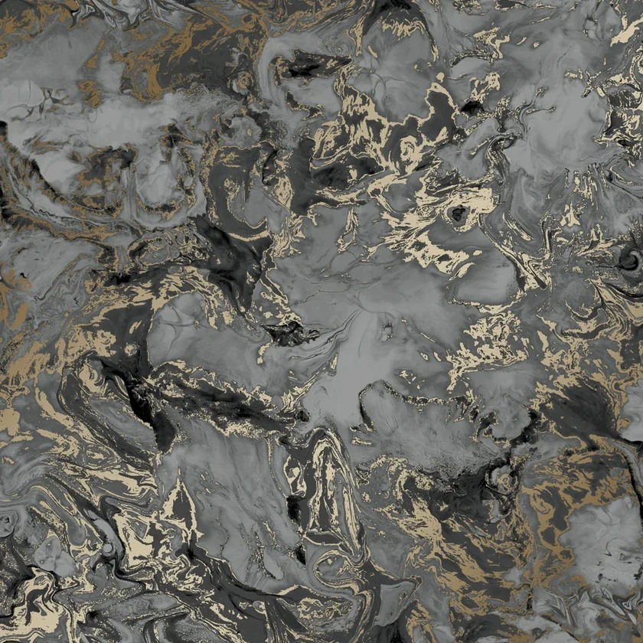Liquid marble wallpaper in charcoal and gold creates a striking visual contrast that exudes luxury and sophistication. The deep, rich charcoal serves as a bold backdrop, while the shimmering gold veins weave through the design, adding an element of opulence and drama. This combination of dark and metallic tones makes it perfect for those looking to make a statement in their interiors. Whether used in a contemporary living room, a chic dining area, or a stylish bedroom, the charcoal and gold liquid marble wallpaper infuses any space with a sense of grandeur and modern elegance.